2.Open mycv file using vi command then: Without using arrows state how to:
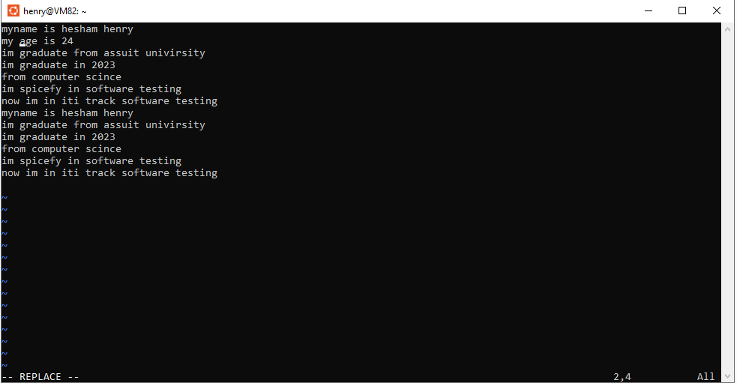
a. Move the cursor down one line at time.
press “ j ”
b. Move the cursor up one line at time.
press “ k ”
c. Search for word age
press “ /age
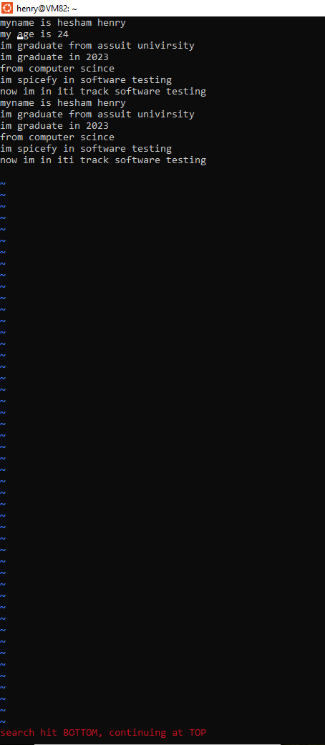
d. Step to line 5 (assuming that you are in line 1 and file is more than 5 lines
press “ :5 ”
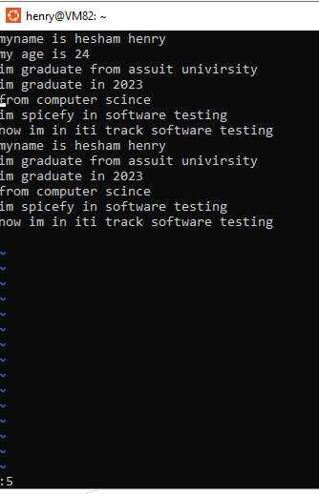
e. Delete the line you are on and line 5.
Delete the current line with: ‘’ dd ’
delete line 5 by typing : “ :5d ”
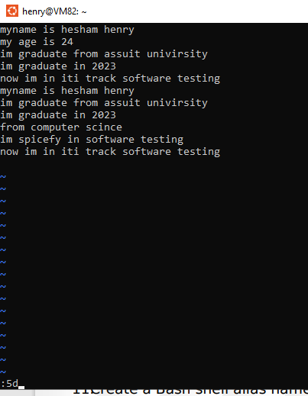
f. How to step to the end of line and change to writing mode in one-step.
press “ A ”
LAB4
1. List the user commands and redirect the output to /tmp/commands.list
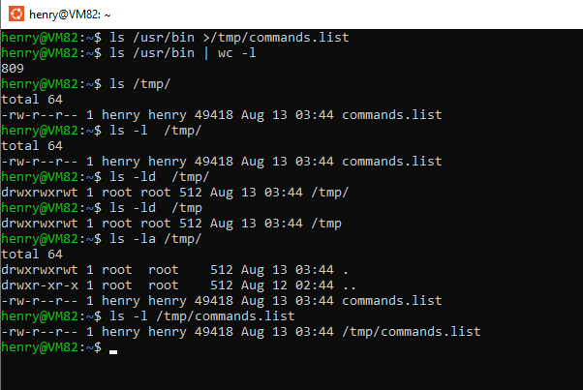
2. Count the number of user commands
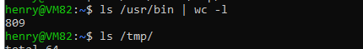
3. Get all the users names whose first character in their login is ‘g’.
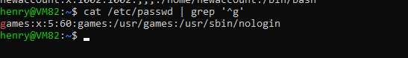
6. Write two commands: first: to search for all files on the system that named .bash_profile
7. Display the number of users who is logged now to the system.
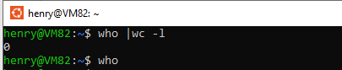
8. Display lines 7 to line 10 of /etc/passwd file
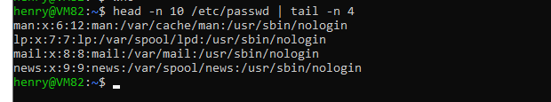
9. What happens if you execute: cat filename1 | cat filename2 ls | rm ls /etc/passwd | wc –l
1 -
ignore output of file 1
print file 2 only
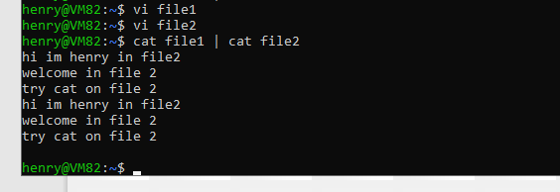
2-
in rm should send operand
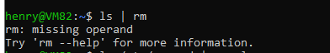
3-
its one line
as permissions of file
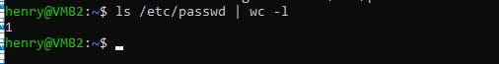
10.Issue the command sleep 100.
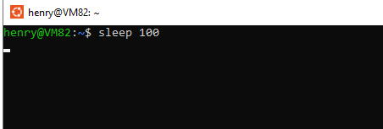
11.Stop the last command
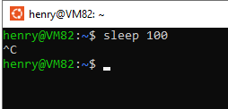
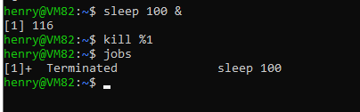
12.Resume the last command in the background
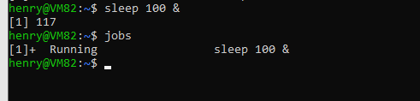
13.Issue the jobs command and see its output.
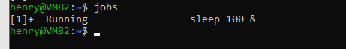
14.Send the sleep command to the foreground and send it again to the background.
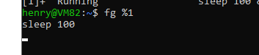
15.Kill the sleep command
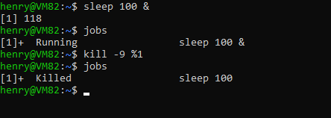
16.Display your processes only
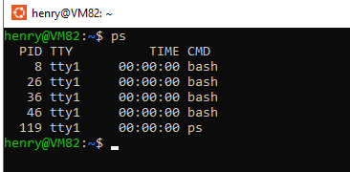
17.Display all processes except yours
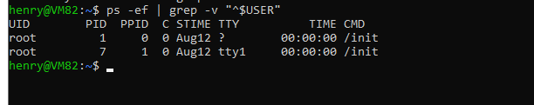
18.Use the pgrep command to list your processes only
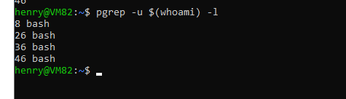
19.Kill your processes only


